ASSIGNMENT – 7 (HTML) (KASHISH)

Q-1 Create an HTML file with a container div and 4 images of your favorite apps (Instagram, WhatsApp, Zomato, Spotify) as social icons. Use CSS Flexbox to display them in a row with equal spacing using justify-content?
Ans.
<!DOCTYPE html>
<html>
<head>
<title>My Favorite Apps</title>
<style>
body {
font-family: Arial, sans-serif;
text-align: center;
}
h1 {
margin-top: 30px;
}
/* Flex container */
.app-container {
display: flex;
justify-content: space-evenly;
align-items: center;
padding: 30px;
margin-top: 30px;
border: 2px solid black;
}
/* App icons */
.app-container img {
width: 80px;
height: 80px;
object-fit: contain;
}
</style>
</head>
<body>
<h1>My Favorite Apps</h1>
<div class="app-container">
<img src="/practices.html/instagram.webp"
alt="Instagram">
<img src="/practices.html/whatsapp.webp"
alt="WhatsApp">
<img src="/practices.html/zomato.webp"
alt="Zomato">
<img src="/practices.html/spotify.png"
alt="Spotify">
</div>
</body>
</html>


Q-2 Build a horizontal playlist bar like Spotify using Flexbox: add 5 song cards with song name and artist, and use align-items to vertically center the text in each card?
Ans.
<!DOCTYPE html>
<html>
<head>
<title>Spotify Playlist Bar</title>

<style>
.playlist {
display: flex;
gap: 15px;
padding: 20px;
border: 2px solid black;
}
.song-card {
width: 180px;
height: 100px;
border: 1px solid gray;
padding: 10px;
/* Flexbox used to vertically center the text */
display: flex;
align-items: center;
justify-content: center;
text-align: center;
}
</style>
</head>
<body>
<h2>My Spotify Playlist</h2>
<div class="playlist">
<div class="song-card">
<div>
<b>Blinding Lights</b><br>
<span>The Weeknd</span>
</div>
</div>
<div class="song-card">
<div>
<b>Shape of You</b><br>
<span>Ed Sheeran</span>
</div>
</div>
<div class="song-card">
<div>
<b>Perfect</b><br>
<span>Ed Sheeran</span>
</div>
</div>
<div class="song-card">
<div>
<b>Stay</b><br>
<span>Justin Bieber</span>
</div>
</div>
<div class="song-card">
<div>
<b>Levitating</b><br>
<span>Dua Lipa</span>
</div>
</div>
</div>
</body>
</html>

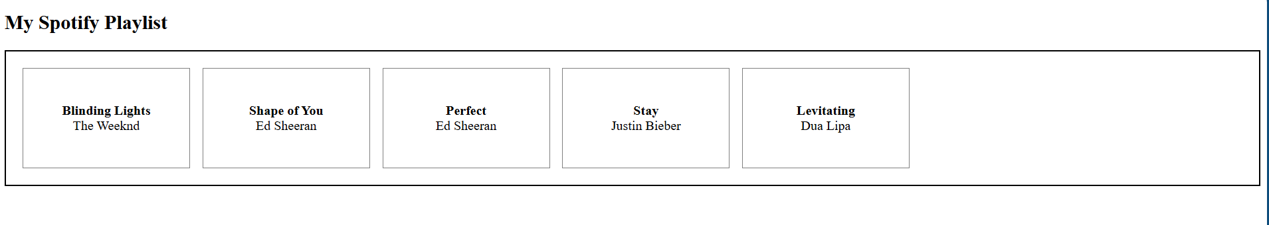
Q-3Design a Flipkart-style product grid: create a section with 6 product cards (use placeholder images and product names), and use CSS Grid to arrange them in 3 columns and 2 rows?
Ans.

<!DOCTYPE html>
<html>
<head>
<title>Flipkart Product Grid</title>
<style>
.product-grid {
display: grid;
grid-template-columns: repeat(3, 1fr);
gap: 20px;
padding: 20px;
}
.product-card {
border: 1px solid gray;
padding: 15px;
text-align: center;
}
.product-card img {
width: 150px;
height: 150px;
}
</style>
</head>
<body>
<h2>Flipkart Products</h2>
<section class="product-grid">
<div class="product-card">
<img src="/practices.html/smartphone .jpeg" alt="Mobile">
<h3>Smartphone</h3>
</div>
<div class="product-card">
<img src="/practices.html/laptop.avif" alt="Laptop">
<h3>Laptop</h3>
</div>
<div class="product-card">
<img src="/practices.html/wireless headphone.jpeg" alt="Headphones">
<h3>Headphones</h3>
</div>
<div class="product-card">
<img src="/practices.html/smart watch.jpg" alt="Watch">
<h3>Smart Watch</h3>
</div>
<div class="product-card">
<img src="/practices.html/shoe.avif" alt="Shoes">
<h3>Running Shoes</h3>
</div>
<div class="product-card">
<img src="/practices.html/camera.jpg" alt="Camera">
<h3>Camera</h3>
</div>
</section>
</body>
</html>

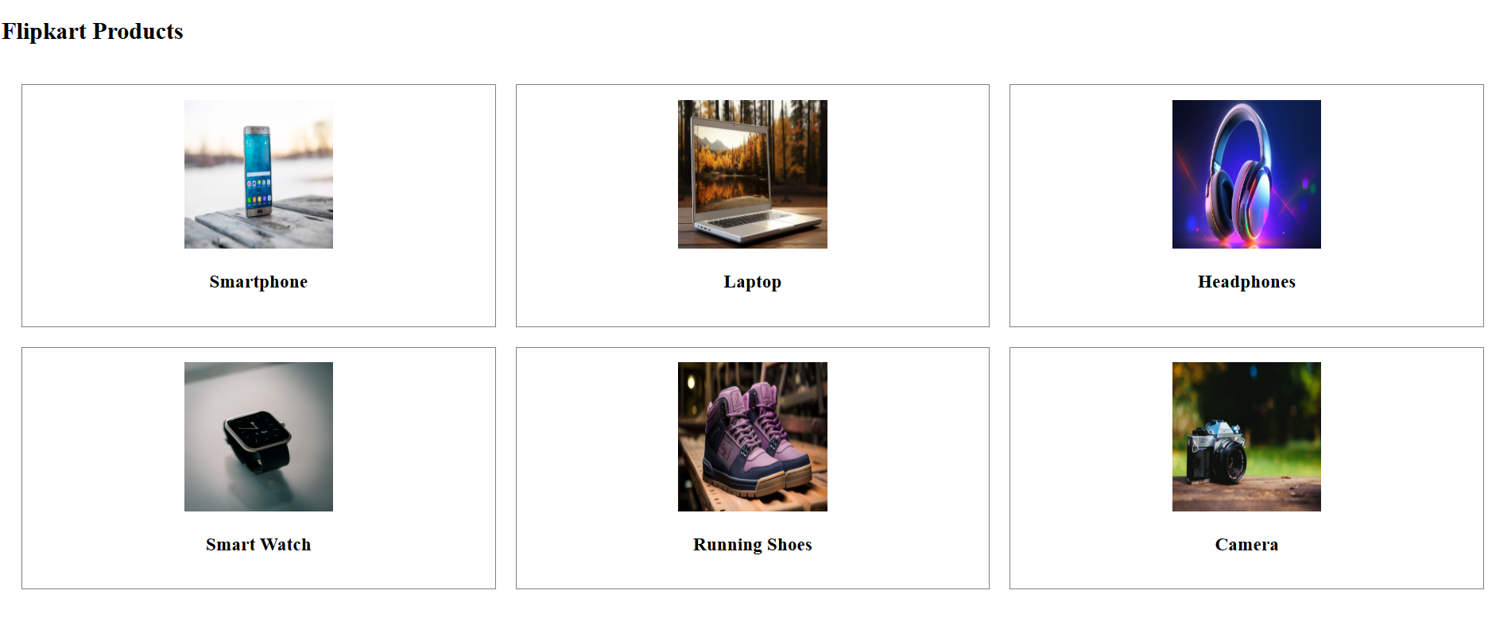
Q-4 Make your product grid responsive: use grid-template-columns to show 3 columns on desktop, 2 columns on tablet, and 1 column on mobile screens.<br><br><em><strong>Hint:</strong> Use CSS media queries to change grid-template-columns based on screen width.</em>?
Ans.
<!DOCTYPE html>
<html>
<head>
<title>Responsive Product Grid</title>
<style>
.product-grid {
display: grid;
grid-template-columns: repeat(3, 1fr);
gap: 20px;
padding: 20px;
}
.product-card {
border: 1px solid #ccc;
padding: 15px;
text-align: center;
border-radius: 10px;
}
.product-card img {
width: 100%;
height: 150px;
object-fit: cover;
}
/* Tablet: 2 columns */
@media (max-width: 768px) {
.product-grid {
grid-template-columns: repeat(2, 1fr);
}
}
/* Mobile: 1 column */
@media (max-width: 480px) {
.product-grid {
grid-template-columns: 1fr;
}
}
</style>
</head>
<body>
<h1>Flipkart Product Grid</h1>
<section class="product-grid">
<div class="product-card">
<img src="/practices.html/smartphone .jpeg" alt="Product 1">
<h3>Mobile Phone</h3>
</div>
<div class="product-card">
<img src="/practices.html/laptop.avif" alt="Product 2">
<h3>Laptop</h3>
</div>
<div class="product-card">
<img src="/practices.html/wireless headphone.jpeg" alt="Product 3">
<h3>Headphones</h3>
</div>
<div class="product-card">
<img src="/practices.html/smart watch.jpg" alt="Product 4">
<h3>Smart Watch</h3>
</div>
<div class="product-card">
<img src="/practices.html/camera.jpg" alt="Product 5">
<h3>Camera</h3>
</div>
<div class="product-card">
<img src="/practices.html/gaming mouse.jpg" alt="Product 6">
<h3>Gaming Mouse</h3>
</div>
</section>
</body>
</html>

